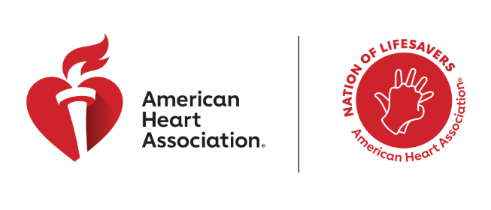

2026 CPR & AED Awareness Week
Suggested Newsletter Copy

The Power to Save a Life is in Your Hands

Suggested Headline/Title: The Power to Save a Life is in Your Hands
Suggested Copy:
If someone collapsed in front of you, would you know what to do?

For many people, the answer is no, not because they don’t care, but because they believe CPR is only for trained professionals. During CPR and AED Awareness Week, the American Heart Association is working to change that belief and remind communities that lifesaving action starts with everyday people.

Cardiac arrest can happen at home, at work or in your neighborhood. When it does, immediate CPR can double or even triple a person’s chance of survival. Yet more than two in three people in the U.S. still think only people with medical training should step in. That hesitation can cost precious time — and lives.

This year’s CPR Week message, In Your Hands, puts the focus on where it belongs. You do not need to be a medical professional to save a life. Hands-only CPR is simple to learn and easy to remember, and it empowers parents, caregivers, neighbors, coworkers — everyone — to act with confidence.

Whether you learned CPR years ago, have never taken a class or want a quick refresher, there are resources designed for every stage of the journey. In an emergency, don’t wait. The power is in your hands.

Call to Action: Learn or refresh your CPR skills, talk with your family or workplace about emergency response, and join the Nation of Lifesavers. The power to save a life is already in your hands.

- Learn CPR at heart.org/nation.

