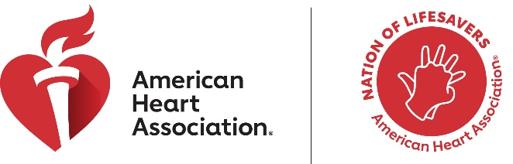

National CPR and AED Awareness Week
June 1-7, 2026
Suggested Social Media Copy

- June 1-7 is National CPR and AED Awareness Week! You could be the difference for someone you know or love. Join the Nation of Lifesavers by learning CPR. Find a course at www.heart.org/nation. #NationofLifesavers

- It’s CPR Week. The power to save a life is in your hands. If you see a teen or adult collapse, call 911 and push hard and fast on the center of the chest. Learn more at www.heart.org/nation. #NationofLifesavers

- You can save a life by knowing #CPR. Joining the Nation of Lifesavers is easier than ever. Watch this Hands-Only CPR video, and find more training options for your family or workplace at https://www.heart.org/en/nation-of-lifesavers. #CPRWeek #NationofLifesavers (Embed this video in post.)

- When cardiac arrest happens, acting quickly can make all the difference. All you need to be a hero is knowledge, courage and willingness to act. The power is in your hands. Join the #NationofLifesavers

